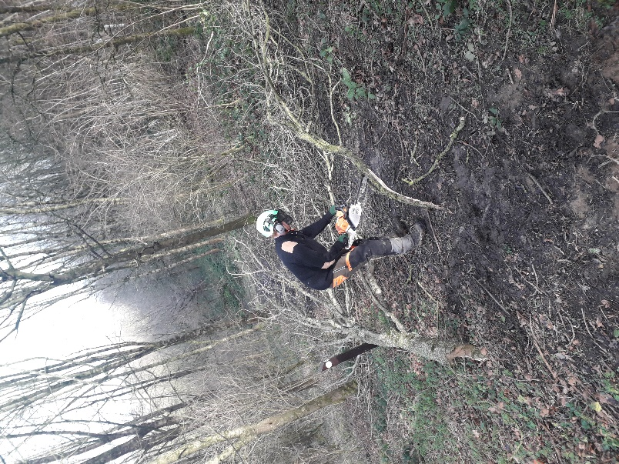
The grounds team started the week by cleaning up the mess left behind from Storm Ciara. With only a few limbs blocking the junction of the yellow and green trails up on Herne Hill, it has to be said, the damage could have been a lot worse.
Since Storm Ciara, 50 trees of varied species have also been planted this week after the Town Council were successful in applying to be part of the South Somerset District Council’s “Great Parish Tree Giveaway”. This initiative recognizes a climate emergency, and the District Council are hoping to plant significantly more trees as part of their newly adopted Environmental Strategy.
Some trees were planted up at the cemetery, where for safety reasons, a few trees had been removed, while the other trees were planted to help secure the banks on Herne Hill where erosion is an issue.
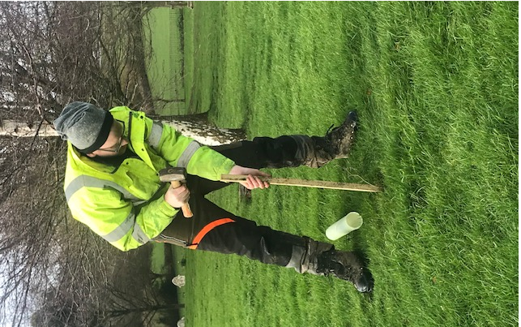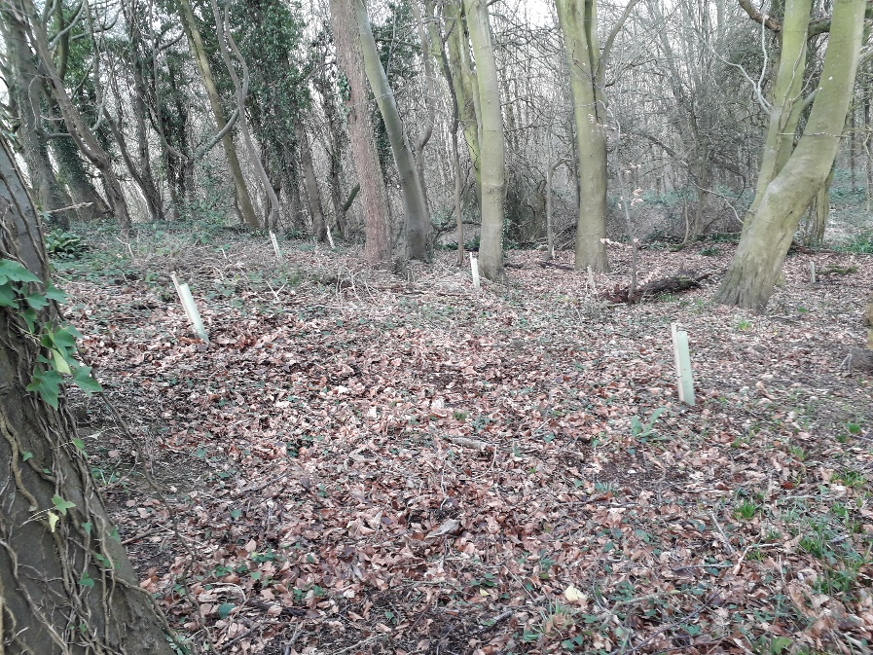
With Storm Dennis approaching, we would like to remind visitors to take care whilst in the woodland, avoiding it during the high winds which have been forecast for the weekend. The grounds team will check for damage early next week, but if you do come across any obstructions whilst on the hill, you can report it to us on 01460 52149 on Monday 17th February.

